Select SQL:

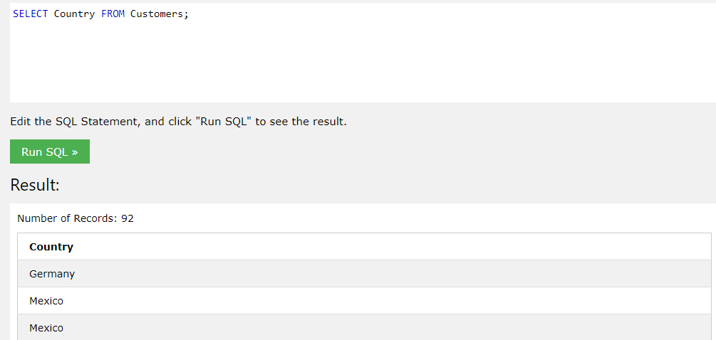

SELECT alongside certain parameters allows you to look for specific or all the result within a database, this is helpful if you need to find someone’s details.

SELECT TOP 3 \* FROM Customers;

INSERT this is used to add new information into the tables, use all of the values i.e. CustomerName, ContactName, Address, City, PostalCode, Country. This makes sure no redundant information or errors appear.

INSERT INTO Customers (CustomerName, ContactName, Address, City, PostalCode, Country)

VALUES ('Cardinal', 'Tom B. Erichsen', 'Skagen 21', 'Stavanger', '4006', 'Norway');

UPDATE this is used to update information on entries on the tables i.e.

UPDATE Customers

SET ContactName = 'Alfred Schmidt', City= 'Frankfurt'

WHERE CustomerID = 1;

DELETE this allows you to delete entries made into tables and just state a parameter.

DELETE FROM Customers WHERE CustomerName='Alfreds Futterkiste';